~~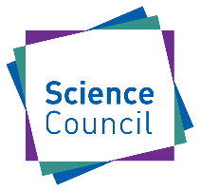~~Chartered Science Teacher

1) Professional Knowledge and Understanding:

a) A broad and up to date knowledge and understanding of science and its impact on their work;

b) A broad and up to date knowledge and understanding of teaching, learning and assessment specifically related to science education;

c) Knowledge and understanding of students and how different contextual factors can impact on their learning in science.

2) Professional Practice which includes:

a) Planning coherent programmes of teaching in science that develop investigative skills and are intellectually challenging, emotionally supportive and physically safe;

b) Engaging students in the collection, analysis and evaluation of evidence to extend their scientific knowledge;

c) Developing students’ confidence and their ability to understand and use scientific knowledge and processes in a range of scenarios;

d) Assessing students’ learning and providing effective feedback.

3) Professional attributes which includes:

a) Analysing, evaluating and refining teaching to improve student learning;

b) Collaborating with colleagues and the wider professional communities to improve the quality and effectiveness of science education;

c) Taking responsibility for leadership, management and development of science teaching.

(Note registrants will need to comply with the Science Council CPD Standards)

*(Approved by Science Council Board, Sept 2025)*