Better D&I Measures – How To
This document is designed to help you produce better measures. Depending on which stage you are on this journey, you can head to the relevant section and begin there:
- If you have yet to start monitoring and measuring, go to Section A
- If you have started monitoring and measuring but are facing some challenges, go to Section B
- If you have been monitoring and measuring for some time and would like to maximise the value of your data, go to Section C
As Science Council and Professional Engineering Institution membership organisations and employers, we work for the benefit and well-being of society. We value diversity and aim to create an environment free from harassment and discrimination and one in which everyone feels included and valued. All members and staff should feel able to challenge prejudice and approach their work with open and critical minds, and this means we must recognise and represent the diversity of our members.
We know, for example, that members may work in countries where people are prosecuted, victimized or harassed on the basis of sexual orientation or gender identity. While members will abide by local laws, we should strive to follow best practice in supporting fair treatment for all underrepresented groups.
We hope this document will help those beginning their Diversity and Inclusion Progression Framework journey and, support you from where you currently are and to start capturing the data you need to move forward. Most organisations have data on age and gender, as a minimum and this represents a good starting point.
There are 5 key steps:
- understand why diversity, equality and inclusion should be monitored and measured
- articulate your data requirements to your IT team or department, so they can make the changes needed
- prepare your data in such as way so as to make it easier to consolidate, aggregate and publish the measures
- be clear about how your members journey looks for your organisation, so that the measures can be mapped to the right places in the members journey
- Use that critical insight to identify and address the challenges that could be getting in the way

Section A: Why monitor and measure?

First steps for those yet to start monitoring and measuring
If you are at the beginning of your journey with diversity monitoring and measuring, start small. You could survey your members based on one activity or event that is managed by the office staff (as opposed to those managed by volunteers). For example, a central event you run or your annual membership survey. If you can use a unique identifier (such as Member ID), it will help you expand your monitoring in the future. If you don’t have a central depository for your diversity data, that doesn’t stop you from taking part in this exercise. Why not use a sample of your data or focus on one section of the framework?
Diversity monitoring can help you as a membership organisation to:
- attract the widest possible diversity of applications for membership by being able to show the diversity of the membership
- review your membership, target under-represented groups and encourage them to apply for membership
- develop a reputation as an inclusive organisation that welcomes members and applicants for awards, grants and prizes from the widest possible diversity of people that reflects the diversity of people involved in engineering and science
- monitor the selection processes for awards, grants and prizes -organisations are able to identify if they are receiving the level of diversity within applications that they would expect to reflect the diversity of people in engineering and science. It will also allow you to measure who is successful in these processes

Diversity monitoring can help you as an employer to:
- build reputation: the best performing organisations are those that invest most on promoting diversity and inclusion in their workforce;
- improve productivity: valuing and supporting the diversity of people’s backgrounds and lifestyles is important in making the most of the contribution that they can make to organisational performance;
- recruit and retain the best from the widest talent pool;
- identify and address any inequalities in the application of employment policies and facilitate specific adjustments or interventions;
- avoid risk: by helping to avoid damaging and costly employment tribunals or negative publicity

Measures of D&I are key to monitoring progress against key objectives. This can be used to give weight to the business case for D&I and demonstrate an organisation’s commitment to establishing and maintaining an inclusive culture.
Guidance on gathering diversity information is available on the Royal Academy of Engineering website.

Scientific Body – Case Study – TOPRA
Sinéad Whelan - Head of Membership & Data Insight
TOPRA, the Organisation for Professionals in Regulatory Affairs, took part in the Diversity and Inclusion Progression Framework benchmarking in 2017. We focussed on a few of the areas of the framework to begin with as we did not have all the necessary diversity data collected.
Areas we have been able to benchmark through various routes:
- Governance and Leadership
- Membership
- Communications, Marketing
- Employment
Basic information is gathered through our membership application, stored committee details and sample surveys. The main areas we collected and monitored were:
- Age
- Gender
- Ethnic minorities
- Disability
By taking part in the benchmarking, we were able to see which sections we could prioritise in the future and which areas may be more complex to monitor and measure in the short to medium term.
Next steps to monitoring:
Our aim in 2019/2020 is to focus on collecting more diversity information in the following areas:
- Awards and committees
- Events – gender balance on panels
We will also be moving towards collecting all our data on diversity in a separate section of our CRM (with access for key staff only).
Even if your organisation does not collect all the necessary data, it is a useful exercise to complete the Diversity framework and target areas for improvement and to recognise where you are doing well. It wasn’t as daunting as we first thought.

Diversity Monitoring and Data Protection
Diversity information (apart from Gender and Age) for an individual falls within the scope of ‘sensitive personal data’ under GDPR 2018. The Data Protection Action 2018, which supplements the provisions of the GDPR, includes a limited provision that specifically allows these types of special category data to be processed for the purpose of monitoring equality of opportunity or treatment between different groups.
It cannot be assumed that an individual who is willing to complete a diversity questionnaire explicitly consents to you storing, analysing, reporting and publishing their data. You must give clear information on any questionnaire detailing how you will use the data and how long you will store it.
The individual must be asked to give explicit consent to the use and storing of this information by ticking the positive “opt-in” box on the form.

Professional Engineering Institution – Case Study - ICE
As part of a digitisation process, ICE decided to look at the diversity of applicants to its undergraduate scholarship scheme. This scheme attracts around three hundred 18-year olds a year predominantly from the UK and is publicised through UCAS to those holding civil engineering offers to reach all eligible students, not just those from the more clued-up schools. UCAS charge about £10K for this.
Using a SharePoint platform for the application process, applicants were given a unique ID, with diversity details extracted separately. The unique number enabled tracking from those who applied to those invited for interview using a MS Excel spreadsheet to extract diversity data.
This then looked at the first part of a member journey, before taking up student membership.
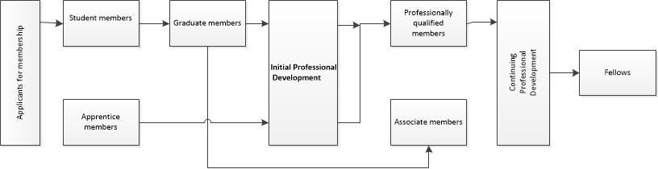
There are two sifts before invitations to interview are offered. The first is by staff and excludes ineligible applications (primarily students applying for unaccredited degrees, or where there is no firm degree offer). Then a committee look at the remaining applications taking the total from c300 to c120. As might be expected, no significant issues were apparent with LGBTQ students at this stage, nor were there anomalous findings relating to religion.
In terms of gender identity, those identifying as female comprised 44% of applicants and 52% of those invited for interview. No students this year identified as other than M/F. No students identified as transgender. The gender disparity is partly explained by males often from overseas comprising most of the ineligible and inaccurate applications.
With regards to ethnicity, 34% of applicants declared ethnicity other than White UK, but these students comprised only 24% of those invited for interview. This seemed to be a concern, but cross-matching with nationality, those rejected were predominantly overseas / EU nationals and male – the same group as above. Of the British nationals from minority backgrounds, 48% were selected for interview.
Another area of concern, though the numbers are relatively small, was that fewer of those declaring a disability or SpLD were selected for interview (as compared with application). Given that the data is separated from the application, and that most of the declarations were for dyslexia, there is a possibility that an application process that asks for a significant amount of writing disadvantages these students. This may also be a factor for those whom English is an additional language, and plausibly for males, given the gender gap at English GCSE. This is worth investigating further.
For now, this is a small part of ICE’s diversity monitoring, but it has the potential to be adopted at other stages of the member journey, particularly the transition from graduate to professionally qualified members.

Section B: Preparing your data for D&I measures

For those who have started monitoring and measuring and how to make the process easier
If you have started collecting diversity monitoring data for measuring and are facing technical challenges, the following steps will give you some ideas that will help you overcome the data issues.
- Clean up your member data.
  - Allocate a unique identifier to every member and remove or merge duplicate records for the same member
  - Ensure every member’s D&I monitoring data is up to date and stored in a separate, protected area from the member’s personal details i.e. name, address etc. – you can conduct a yearly survey asking members if their details are the same which you can also do whenever a member renews their membership
  - The member’s D&I monitoring data should be linked to the member’s personal details by the member’s unique identifier only
- Make sure the member’s unique identifier is captured and stored against every event type or activity a member engages with the organisation, such as:
  - attending an event,
  - submitting an article
  - presenting or speaking at an event
  - chairing or running a subcommittee
  - receiving an award or accreditation
  - changes membership category
- It is helpful for every event type or activity organised by the organisation, either as a core activity or as a one-off or ad-hoc activity, to have a unique identifier when captured on your system.
- Focus first on core events and activities managed by the organisation’s office staff first, before looking at events and activities managed by volunteers on behalf of the organisation.

Section C: Measuring the membership journey and identifying obstacles

Advanced steps for those who have been monitoring and measuring for some time
If you have been collecting diversity monitoring data for some time and want to look at how to maximise the value of the data collected, the following steps offer some ideas on the concept of defining and measuring the membership journey.
- Sketch out what you think your members’ journey would or should look like in your organisation, identify how much of the journey is linear and how much is parallel. Here is an example of how a member’s journey could look, for a hypothetical membership body:
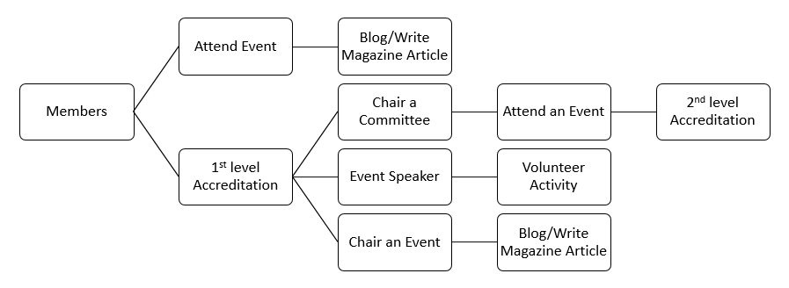
- Look at the measures in the Benchmarking Framework (also shown in the appendix) and map them to the different areas of your organisation’s member journey.
- When calculating the measures, think about the calculation as conditional probability (i.e. the probability of an event [B], given that another [A] has already occurred). If only 10% of your members are female, what is the probability of female members seeking accreditation compared to the actual number of female members seeking accreditation.
- It is important to note that the purpose of the D&I measure is not to pick a percentage that reflects your organisation in the best possible light, but instead to help you understand what obstacles are getting in the way of a member when they embark on the membership journey within your organisation.

Summary
This document hopefully offers some ideas on how to get started with producing the Diversity and Inclusion Benchmarking Framework measures. It offers four key tips to get started. It is important to understand why you are monitoring and measuring before starting so your efforts are focused, efficient and effective. Getting the data ready by implementing a unique member id and making sure members can update their diversity data when they need to, will immediately help you with some of the initial key measures such as the diversity mix of your members. Remember to store members’ diversity data separately and segregated from main details. Creating a membership journey and mapping the measure to it, will immediately offer insight and help identify potential obstacles and challenges, so you can focus on making small changes in the right places to get the maximum benefit.
For examples of how the tips above have helped organisations, a further case study is provided in the Appendix.

Appendix

The Diversity and Inclusion Benchmarking Framework Measures:
3.1 | GOVERNANCE AND LEADERSHIP
 | How many board members do you have?
 | What % of women do you have on the board of your organisation?
 | What % of minority ethnic people?
 | What % of board committees are chaired by women?
 | What % of board committees are chaired by minority ethnic people?
 | What is the age range of people on the board of your organisation?
3.2 | MEMBERSHIP AND PROFESSIONAL REGISTRATION (where possible, please report separate figures for each register)
 | How many members do you have?
 | How many registrants do you have?
 | What % of members are women? What % of registrants are women?
 | What % of members are minority ethnic? What % of registrants are minority ethnic?
 | What % of members are disabled? What % of registrants are disabled?
 | What is the age range by gender of members and registrants?
 | What is the age range by ethnicity of members and registrants?
3.3 | EDUCATION AND TRAINING
 | How many professional examinations and accreditations have taken place over the past 12 months?
 | What are the pass rates for women/men for professional examinations and accreditation for the past 12 months?
 | What are the pass rates by ethnic group?
3.4 | PRIZES, AWARDS AND GRANTS
 | How many prizes, awards and grants have you given in the past 12 months?
 | What % of main prizes, awards and grants have gone to women in the past year?
 | What is the average (mean) age of those winning prizes, awards and grants?
 | What % of main prizes, awards and grants have gone to minority ethnic award winners?
3.5 | EMPLOYMENT
 | How many employees do you have?
 | What % of the workforce is female?
 | What % of the workforce is minority ethnic?
 | What % of the workforce is disabled?
 | What % of senior leadership is female?
 | What % of senior leadership is minority ethnic?
 | What % of senior leadership is disabled?
 | How many reasonable adjustments have you put in place in the last 12 months for staff and members, and of what types (e.g. mobility, hearing, visual impairments, dietary requirements)?

A PEI Case Study 1 – anonymous
A membership body recently conducted a survey and identified 80% of its members as male and 20% female. Further results also showed that 40% of the female membership population were senior and high ranking and sat on various committee members. Separately, the survey results also highlighted that less than 10% of the female members were nominated for prizes and awards granted by the membership body.
When analysed further, it became apparent that the standing criteria for prizes and awards stated committee members could not be nominated. Therefore, a large proportion of senior and high-ranking female members eligible for the awards, could not be considered for nomination because they sat on the various committees.
The membership body, in the spirit of change for better diversity and inclusion, decided to review the criteria of the prizes and awards to avoid penalising its female members who sat on committees.

McKinsey research – Delivering Through Diversity www.mckinsey.com/business-functions/organization/our-insights/delivering-through-diversity
Creating cultures where all engineers thrive – Royal Academy of Engineering www.raeng.org.uk/inclusivecultures
Diversity Monitoring Guidelines https://www.raeng.org.uk/policy/diversity-in-engineering/professional-engineering-institutions/resources
Art. 9 GDPR Processing of special categories of personal data https://gdpr-info.eu/art-9-gdpr/
Lemon, K. N., & Verhoef, P. C. (2016). Understanding customer experience throughout the customer journey. Journal of Marketing, 80(6), 69-96.
Diversity and Inclusion Progression Framework – Royal Academy of Engineering www.raeng.org.uk/publications/other/diversity-progression-framework

