Science Council

CAP (Common Application
Process)
Manual for Licensed Bodies

Contents
History of the CAP 3
Science Council & licensed bodies roles in the cap 3
Where a Licensed Body uses the CAP, the Licensed Body will need to: 3
Where a Licensed Body uses the CAP, The Science Council will: 4
Licensed body cap options 4
CAP application tasks 5
CAP process map for applicants 6
CAP process map for Licensed Bodies 7
Eligibility criteria for each register 8
Academic requirements 9
Guidance on work experience 9
CAP assessment routes 9
Online Assessment 9
Face To Face Assessment 9
CAP Fees & Invoicing process 10
CAP resubmission process 10
Definitions: 10
CAP assessor recruitment & training process 11
Assessor recruitment & training process 11
CAP M level equivalence report for CSci applicants 11
CSci Equivalence Report (QAA Level 7) 11
CAP Equivlance for RSci & RSciTech Applicants 13
RSci Equivalence Report (Ofqual, level 5) 13
RSciTech Equivalence Report (Ofqual, Level 3) 14
Complaints, appeals and disciplinary procedures via the Common Application Process (CAP) 15
Frequently asked questions 17

History of the CAP

Introducing a Common Application Process
The decision to introduce a common application process was taken by the Science Council Board of Trustees in 2013, following an evaluation of the RSciTech and RSci registers carried out by the New Registers Advisory Group. The common application process (CAP) was developed in partnership with the eight initial RSciTech and RSci Licensed Bodies. A new committee, the Registration Assessment Committee, was established to oversee the development of the process, reporting into the Registration Authority. An online application and assessment system was launched in October 2015.

The process
A key principle is that the Science Council facilitates the process but does not make the award - we support the applicant, liaise with the assessors, and provide the recommendation to the Licensed Body. It is for the Licensed Body to determine, under the terms of its license, how the recommendation is handled.
The RAC (Registration Assessment Committee) plays a key role in quality assurance by reviewing a subset of recent applications from the CAP. Feedback is provided to Assessors following RAC meetings.

Expanding to include CSci
Following a strategy session in August 2015, and with the support of the Science Council Board of Trustees, the RA (Registration Authority) established a working group to explore how the CAP might be extended to include CSci. Alongside the push from employers, there was a desire to ensure greater consistency in the assessment of the newly revised CSci standards. In September 2016, the Science Council online system was expanded to include CSci.

WHERE WE ARE TODAY
In 2019, the Registration and Licensing team began a project on the CAP. A part of the project was transitioning to a new system. Our previous platform on FluidReview was closed for applicants in September 2019 while the new CAP system was built on SurveyMonkey Apply. We worked with our stakeholders to update the application process where there was the need for improvements and the changes were implemented to the new system, which was successfully launched on 1st November 2019. In May 2021 we temporarily closed the CAP to implement the updated standards and equivalency routes, the updated CAP reopened on June 7th 2021. The Science Council took the decision to move from SurveyMonkey Apply to Form Assembly in 2023, the new system opened for applicants in January 2024.

science council & licensed bodies roles in the cap

Where a Licensed Body uses the CAP, the Licensed Body will need to:
Mandatory – for Licensed Body using the CAP
Where a Licensed Body uses the CAP, the Licensed Body will need to:
- Provide the Science Council with at least two volunteer assessors for each register that they hold.
- Be clear on the CAP processes and procedures.
- Be clear on who their CAP assessors are and ensure that their assessors attend the CAP assessor and refresher training that is provided by the Science Council.
- Ensure that they have a process for ratifying any applications that are sent to them via the CAP. (Remember: any application decision that is sent to a Licensed Body via the CAP is sent as a recommendation and the final decision lies with the Licensed Body.)
- Issue the registrant with a certificate and welcome them to registration (and membership if not already a member).
- Find out from the registrant whether they would like to appear on the online register.
- Ensure that they use the correct unique registrant number (Science Council ID) for the registrant and that this is provided at the next quarter data return. Licensed Bodies will receive the Science Council ID for applicants once the application has been passed over to them.
- Help provide the applicant with a mentor if needed.

Where a Licensed Body uses the CAP, The Science Council will:
Where a Licensed Body uses the CAP, The Science Council will do the following on behalf of the Licensed Body:
- Complete the initial application checks and qualification checks for the application.
- The Science Council is committed to the fair and equal treatment of all applicants [irrespective of race, colour, nationality, ethnic or national origin, religion, age, disability, gender, sexual orientation, marital status, ex-offending background or any other potentially unlawfully discriminating factor]. The application process will need to be accessible to candidates from all backgrounds. If an applicant requires adjustments during the application process, or has any access or other requirements, there will be a point of contact at the Science Council who can assist with this.
- Assign two assessors to each application. Assessments may happen online or face to face (in special circumstances). The Science Council will administer this process.
- Provide training and refresher training for CAP assessors.
- Contact the Licensed Body once the application has been recommended as being successful and pass the application over to the Licensed Body.
- Provide feedback to the applicant.
- The Registration Assessment Committee (RAC) will meet regularly to quality assure applications and deal with non-standard applications.

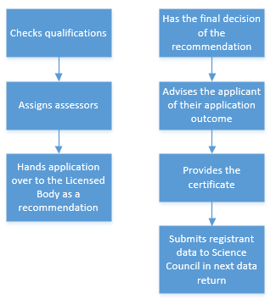
Licensed Body
Science Council

Licensed body cap options
The Licensed Body can choose their position with the CAP from two options:
- Opt into the CAP
For those Licensed Bodies who wish to use the CAP, upon request they can receive a report containing the number of applicants they have in the CAP system. The Science Council would not provide any personal information at this time. For applications that Science Council Assessors recommend approval of, the full application will be sent over to the Licensed Body at the end of the CAP process. If the applicant is not a current member of the Licensed Body, the Science Council will make this clear to the Licensed Body when handed over. The Science Council would not collect the membership fee.
- Opt out of the CAP
For those Licensed Bodies who do not wish for the Science Council to process applications on their behalf, they would not appear on the CAP at all.

CAP application tasks
The CAP administers applicants who apply for RSciTech, RSci and CSci. The CAP does not support applications for CSciTeach. An applicant will need to complete the following tasks prior to submitting their application:
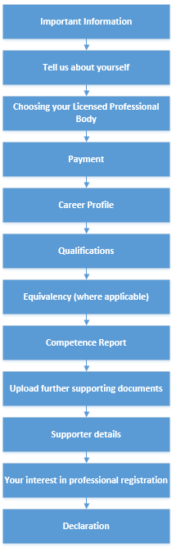
Useful Information:
Choosing your Licensed Professional Body
For our Licensed Bodies that use the CAP, they will appear in this task for applicants to select them as their Licensed Body. Here they will advise if they are a current member, past member or would like to become a member. For our Licensed Bodies who have opted out of the CAP, they would not appear on this task.
Equivalence Reports
Applicants who do not hold a level 7 (CSci) level 5 (RSci) or level 3 (RSciTech) qualification must complete an equivalence report. The purpose of the report is to evidence that you have gained the equivalence knowledge to an appropriate level through work-based learning. Equivalent refers to the QAA (Quality Assurance Agency for Education) descriptors for CSci and the Ofqual (The Office of Qualifications and Examinations Regulation) descriptors for RSci and RSciTech.
Once a submission is received, the Science Council Registration Team will complete general checks of the application. These checks include validating qualifications, ensuring a CV is uploaded, the qualification is from an accredited institution listed on UK ENIC and that the competence report has been filled in. The Science Council will contact the applicant should there be further documents or information required.

CAP process map for applicants
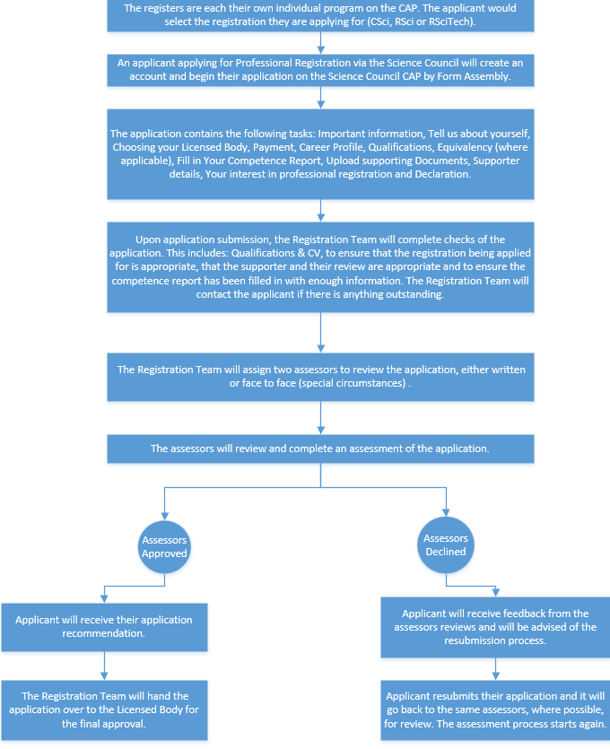

CAP PROCESS MAP FOR THE LICENSED BODY

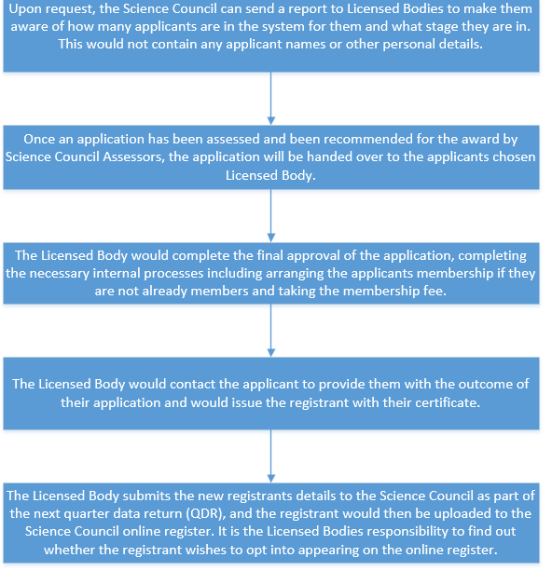

Eligibility criteria for each register

Academic requirements
Mandatory
The following academic criteria is required for each register:
- RSciTech applicants must have a level 3 qualification or equivalent* learning and achievement.
- RSci applicants must have a level 5 qualification or equivalent* learning and achievement.
- CSci and CSciTeach applicants must have a level 7 qualification or equivalent* learning and achievement.
*Although the RA mandates that all Licensed Bodies have an equivalency route, it is up to the Licensed Body what this equivalency route is.
Qualifications need to be within a scientific discipline or relevant practice. In the case where a relevant qualification in science is not held by an applicant, the Licensed Body may approve an equivalent programme of study that clearly demonstrates the correct level of knowledge and practice of science.
International qualifications
International qualifications and institutions will need to be recognised by UK ENIC (formally NARIC). If a Licensed Body has any concerns over the academic qualification of international applicants, then they are advised to check the applicant’s qualifications on the list of recognised HEIs on the UK ENIC web site. If they cannot find the applicants’ University listed then they are advised to ask the applicant to provide a Statement of Comparability, which they can obtain from UK ENIC.
The Licensed Body will need to ensure that the applicant meets the academic requirements for registration indicated above. Copies of certificates submitted as evidence in application for professional registration must be validated.

Guidance on work experience
Applicants need to meet the level of competence for the level of professional registration they are applying for. To develop this level of competence, we find that it normally takes around:
- 5 years’ work experience for CSci/CSciTeach
- 2 years’ work experience for RSci
- 1 years’ work experience for RSciTech

cap assessment routes
Applicants applying for registration via the CAP can select to:
- complete a detailed written report or
- meet two assessors in person or remotely, having completed a short report (face-to-face assessment) this option is offered for special circumstances only.

WRITTEN ASSESSMENT
For the written assessment the applicant’s competence report needs to be detailed and thorough as this is the basis on which the assessors will make their decision on their competence.
We recommend a word count of 300 words per competence.

FACE TO FACE ASSESSMENT
If the applicant requires a face-to-face assessment, they will submit a shorter competence report. The applicant will have the opportunity to talk through their professional experiences and examples with our assessors who will ask them questions to explore their competence. A face-to-face assessment will be conducted remotely. Applicants will be required to provide proof of ID to the Science Council and the assessors.
We recommend a word count of 300 words per section of the competence report, a total of 1,500 words.

CAP Fees & Invoicing process
There are separate fees in which an applicant will pay to the Science Council before their application is handed over to the Licensed Body for further processing.

Fee Breakdown
- Registration fee, this differs between CSci, RSci & RSciTech.
- Application fee, a onetime application fee which differs between CSci, RSci & RSciTech, shortened routes.
The application fee is non-refundable, if an applicant is unsuccessful the registration fee would be refunded. For the most up to date fees, please check the Science Council website.

Payment options
An applicant will be prompted to pay towards the beginning of their application. Payments are taken by credit or debit card within the application form.

To Note
- The Licensed Body would collect renewal registration fees after the first year which would then be paid to the Science Council.
- Professional Body membership fees are not collected by the Science Council.
- The Science Council will not hand applications over to the appropriate Licensed Body until the application invoice (if applicable) has been paid in full.

cap resubmission process
Applicants applying for Professional Registration via the Science Council may not meet the competencies in their first submission. In most cases, there is a requirement for more information to be provided for the assessors to recommend approval of the application.
The resubmission process for declined applications is as follows:
- Both assessors decline application.
- Applicant is advised of the outcome by the registration team and is provided with the feedback copied and pasted from the assessors review.
- Applicant is provided with a 2-week deadline to resubmit their application.
- Once applicant resubmits, the same assessors complete a review of the resubmission. If both assessors recommend approval of the application, the application is handed over to the Licensed Body as a recommendation.
- If the assessors decline the application for a second time, the registration team will inform the applicant that their application has been unsuccessful. The registration team will encourage the applicant to contact their Licensed Body to see if they provide mentoring. Following mentoring (where possible) from the Licensed Body, the applicant can reapply for registration in 12 months of the application being declined the final time.

Definitions:
Resubmit/Resubmission – applicant can use the same application to provide more information in the competence report.
Reapply – start a new application from the beginning.

cap assessor recruitment & TRAINING process
Each Licensed Body who uses the CAP is required to provide at least two assessors to review CAP applications. The individuals would be Professionally Registered themselves.

Assessor recruitment & training process
- Licensed Body identifies individuals to become Science Council application assessors. Or registrants approach the Science Council directly.
- Science Council provides date/s of assessor training.
- Individuals attend Science Council assessor training.
- Individuals are provided with training materials and are set up as an assessor on the CAP.
- Assessors will be invited to refresher training periodically (likely every 3 years)
CAP Assessors will only be assigned to applications at the level of registration they hold or below.
For online assessments, the Science Council will provide the assessor with a 3-week deadline to complete the assessment. If the assessor is unable to complete the assessment the assessor would inform that Science Council and the application will be reassigned.

CAP m level equivalence report for csci applicants
Applicants for CSci who do not hold a Level 7 or above qualification must complete a CSci equivalence report. The purpose of the report is to evidence that the applicant has gained the equivalence knowledge to a Level 7 qualification through work-based learning. Equivalent refers to the QAA (Quality Assurance Agency for Education) descriptors.
Please see below the CSci equivalence report which is implemented on the CAP.

cSci Equivalence Report (QAA Level 7)
In completing the Equivalency Report, you are being asked for evidence against the QAA criteria. The actual criteria have been rephrased slightly to clarify what is being looked for and, or, to make them more equitable to a situation where someone who has obtained an MSc several years ago would be applying for CSci. Further guidance and help have been provided in each section of the form to help you complete the sections.
This is an evidence-based process, so we are asking you to provide evidence in the form of examples to support any statements that you make. In some instances, it might be appropriate to describe a set of circumstance or events to help you demonstrate that you meet the criteria.

QAA Descriptor | Equivalence Requirements
Part 1. Master's degrees are awarded to students who have demonstrated:
- A systematic understanding of knowledge, and a critical awareness of current problems and/or new insights, much of which is at, or informed by, the forefront of their academic discipline, field of study or area of professional practice | 1) How have you developed and maintained your systematic understanding of knowledge, and critical awareness of current problems and/or new insights, much of which is at, or informed by, the forefront of your academic discipline, field of study or area of professional practice?
- A comprehensive understanding of techniques applicable to their own research or advanced scholarship | 2) How have you developed and maintained a comprehensive understanding of techniques applicable to your own research or advanced scholarship.
- Originality in the application of knowledge, together with a practical understanding of how established techniques of research and enquiry are used to create and interpret knowledge in the discipline | 3) How you have used originality in the application of knowledge, together with a practical understanding of how established techniques of research and enquiry are used to create and interpret knowledge in your discipline.
- Conceptual understanding that enables the student:  - to evaluate critically current research and advanced scholarship in the discipline  - to evaluate methodologies and develop critiques of them and, where appropriate, to propose new hypotheses. | 4) Demonstrate that you have developed a understanding of concepts to a level that enable you to critically evaluate current research, new methodologies and, where appropriate, to propose new hypotheses, improvements or ideas.
Part 2. Typically, holders of the qualification will be able to:
- Deal with complex issues both systematically and creatively, make sound judgements in the absence of complete data, and communicate their conclusions clearly to specialist and non-specialist audiences | 5) Demonstrate clearly how you:  - Deal with complex issues both systematically and creatively, making sound judgements in the absence of complete data and in complex and unpredictable situations.  - Communicate conclusions from complex issues clearly to specialist and non-specialist audiences.
- Demonstrate self-direction and originality in tackling and solving problems, and act autonomously in planning and implementing tasks at a professional or equivalent level | 7) Demonstrate self-direction and originality in tackling and solving problems, describing how you act autonomously, exercising your own initiative, in planning and implementing tasks at a professional or equivalent level and how you exercise personal responsibility.

CAP Equivalence for Rsci & RsciTech Applicants
The purpose of the report is to evidence that the applicant has gained the equivalent knowledge to a Level 5 RSci or level 3 RSciTech qualification through work-based learning. Equivalent refers to the Ofqual descriptors.
Please see below the RSci and RSciTech equivalence reports.

RSci Equivalence Report (Ofqual, level 5)
Please note that not all the Ofqual descriptors are included in the below grid as they have already been covered by the RSci competencies.
Knowledge (Ofqual level 5 descriptors) | Knowledge (RSci competencies)
- Has practical, theoretical or technological knowledge and understanding of a subject or field of work to find ways forward in broadly defined, complex contexts. | 1) Demonstrate how you have practical, theoretical or technological knowledge and understanding of a subject or field of work to find ways forward in broadly defined, complex contexts.
(TEXT BOX FOR APPLICANTS ANSWERS – 400 WORD LIMIT)

2) Is aware of the nature and scope of the area of study or work | 2) Demonstrate how you are aware of the nature and scope of the area of study or work within your organisation.
(TEXT BOX FOR APPLICANTS ANSWERS – 400 WORD LIMIT)

3) Understands different perspectives, approaches or schools of thought and the reasoning behind them. | 3) Demonstrate how you understand different perspectives, approaches or schools of thought and the reasoning behind them.
(TEXT BOX FOR APPLICANTS ANSWERS – 400 WORD LIMIT)

Skills (Ofqual descriptor) | Skills (RSci competency)
1) Determine, adapt and use appropriate methods, cognitive and practical skills to address broadly defined, complex problems. | 1) Demonstrate how you determine, adapt and use appropriate methods, cognitive and practical skills to address broadly defined, complex problems.
(TEXT BOX FOR APPLICANTS ANSWERS – 400 WORD LIMIT)

2) Use relevant research or development to inform actions. | 2) Demonstrate how you use relevant research or development to inform actions.
(TEXT BOX FOR APPLICANTS ANSWERS – 400 WORD LIMIT)

RSciTech Equivalence Report (Ofqual, Level 3)
Please note that not all of the Ofqual descriptors are included in the below grid as they have already been covered by the RSciTech competencies.
Knowledge (Ofqual level 3 descriptor) | Knowledge (RSciTech competency)
1) Has factual, procedural and theoretical knowledge and understanding of a subject or field of work to complete tasks and address problems that while well-defined, may be complex and non-routine. | 1) Demonstrate how you have factual, procedural and theoretical knowledge and understanding of a subject or field of work to complete tasks and address problems that while well-defined, may be complex and non-routine.
(TEXT BOX FOR APPLICANTS ANSWERS – 400 WORD LIMIT)

2) Is aware of the nature of the area of study or work. | 2) Demonstrate how you are aware of the nature of the area of study or work within your organisation.
(TEXT BOX FOR APPLICANTS ANSWERS – 400 WORD LIMIT)

3) Is aware of different perspectives or approaches within the area of study or work. | 3) Demonstrate how you are aware of different perspectives or approaches within the area of study or work.
(TEXT BOX FOR APPLICANTS ANSWERS – 400 WORD LIMIT)

Skills (Ofqual descriptor) | Skills (RSciTech competency)
1) Identify, select, and use appropriate cognitive and practical skills, methods and procedures to address problems that while well-defined, may be complex and non-routine. | 1) Demonstrate how you Identify, select and use appropriate cognitive and practical skills, methods and procedures to address problems that while well-defined, may be complex and non-routine.
(TEXT BOX FOR APPLICANTS ANSWERS – 400 WORD LIMIT)

2) Use appropriate investigation to inform actions. | 2) Demonstrate how you use appropriate investigation to inform actions.
(TEXT BOX FOR APPLICANTS ANSWERS – 400 WORD LIMIT)

Complaints and appeals via the Common Application Process (CAP)
Complaints and appeals for the Common Application Process (CAP)
- Complaints and the CAP
  - The Science Council shall deal with any complaints from applicants, third parties or the Licensed Body with regards to the CAP if:
      - there are any complaints around the process adopted for determining applications that are made via the CAP up until the point they are formally handed over to the Licensed Body.
      - there are any complaints about assessor conduct.
  - The Science Council will use the General Science Council Complaints Procedure to deal with these complaints.
- Appeals and the CAP
  - Applicants applying for professional registration via the Science Council CAP have the right to appeal a decision of the assessors to reject their application to the Science Council up until the point that their application is formally handed over to the Licensed Body in accordance with the process set out in the CAP Manual for Licensed Bodies.
  - The grounds for appeal will be:
      - additional information, which could not reasonably have been presented at the time of the assessment, is available, or
      - application procedures (including but not limited to the requirements of procedural fairness) have not been followed.
  - An appeal must be submitted in writing to the Registration and Licensing Manager, no more than 28 working days from receipt of the written decision against which the appellant is appealing. In the event that no such written appeal is received within that period, the decision will be deemed to have been accepted. Extensions of time will only be granted in exceptional circumstances with the agreement of the Chair of the Registration and Assessment Committee (“RAC”) and the Registration and Licensing Manager, upon the provision of relevant evidence.
  - In order to ensure appeals are dealt with in an efficient and timely manner, please include the words “CAP Appeal” in the subject line of any correspondence with the Registration and Licensing Manager. Please also include the following details:
      - your full name;
      - the name of the Licensed Body to which you had applied; and
      - an explanation of the ground(s) of appeal on which you seek to rely and why you consider that ground applies in your case, together with any relevant evidence.
  - The grounds of appeal will initially be considered by the Chair of the RAC and the Registration and Licensing Manager. The Registration and Licensing Manager will aim to provide a response (“Preliminary Response”) to the appellant within 10 working days of receiving the appeal. Where the Registration and Licensing Manager is not able to provide the Preliminary Response within this timeframe, they shall inform the appellant and provide an indication of when they expect to provide the Preliminary Response. The Preliminary Response will explain whether the Chair of the RAC and the Registration and Licensing Manager determine that it is a valid appeal which gives rise to reasonably arguable grounds and are not frivolous or vexatious.
  - If it is a valid appeal made on reasonably arguable grounds, it will then be escalated to the RAC who will assign a panel that will be comprised of RAC members who have had no prior involvement in the matter and no other interest in the outcome (the “Appeal Panel”). The appeal will be further investigated within 28 working days of their assignment. This will include communicating with relevant individuals (including the complainant) and reviewing available documentation (including but not only that provided by the complainant). The Appeal Panel will provide a report of its findings, its conclusions (on the balance of probabilities) and recommendation to the following meeting of the RAC and the RAC will decide by simple majority whether to uphold the appeal (and overturn the original decision) or to reject the appeal. Exceptionally, where a request is deemed to be made for good reason, the Appeal Panel may in its discretion agree to anonymise the source of evidence gathered in the report. The RAC’s decision will be communicated to the appellant within 10 working days of the RAC meeting, together with a summary of its reasons.
  - An appellant has the right to seek a review of the RAC’s decision to the Registration Authority (“RA”). Any request for a review of the appeal decision shall be made in writing to the Registration and Licensing Manager.
  - A request for a review of the appeal decision must be submitted in writing to the Registration and Licensing Manager no more than 28 working days from receipt by the appellant of the RAC’s decision.
  - An appeal under paragraph 2.7 may only be brought where it is alleged that the RAC’s process in reaching its decision was flawed (including, but not limited to, in respect of the requirements of procedural fairness).
  - On receipt of a request for a review of an appeal decision, the RA shall appoint a panel that will be comprised of RA members who have had no prior involvement in the matter and no other interest in the outcome (the “Review Panel”). The Review Panel will consider the appeal within 28 days of their assignment. The Review Panel will consider the information gathered and the process followed by the Appeal Panel and RAC. It may also choose to speak with individuals, including but not only the appellant. The Review Panel will provide a report of its findings, its conclusions (on the balance of probabilities) and recommendation to the following meeting of the RA and the RA will decide by simple majority whether to overturn the decision of the RAC or confirm it. The RA’s decision will be communicated to the applicant within 10 working days of the RA meeting, together with a summary of its reasons. The decision of the RA must be final.
  - A decision of the assessors to reject an application for professional registration via the Science Council CAP shall continue to have effect until such time as the decision is overturned on appeal.
- Appeals against Licensed Bodies’ decisions
  - Once the application is formally handed over to the Licensed Body, the applicant loses the right to appeal to the Science Council. If the situation arises where the Science Council assessors recommend the applicant for professional registration and the Licensed Body rejects the recommendation, the Licensed Body’s decision will override the Science Council’s assessor recommendation.
  - In these situations, the applicant shall have the right to make an appeal to the Licensed Body that they selected in accordance with that Licensed Bodies’ appeals process.

frequently asked questions

How long does an application take to process on the CAP?
8 -12 weeks after the initial submission excluding bank holidays and holiday periods.

What happens if the assessors disagree on the outcome?
The Registration Team will put the two assessors in contact with each other to advise them of the disagreement and ask that they discuss the application and their reviews to come to an agreement. Should they not come to an agreement, a third assessor will review the application and their decision will determine the outcome.

